Here is some quadratics homework that has been handed in. The answer is not correct, can you find the mistakes in the working.

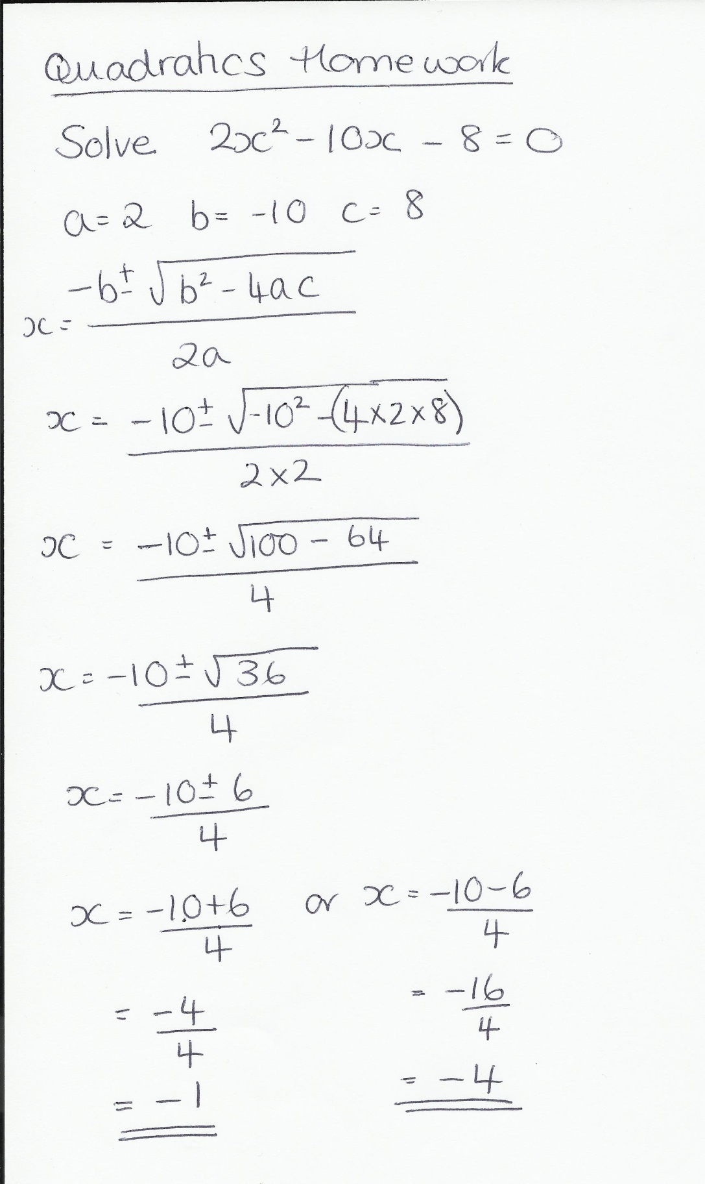

Now re-do the homework to find the correct answer. Give your answer correct to 1 d.p.